**CS 451/551 - User Interface Design**

**Fall 2021**

**Assignment 2-a: COVID Testing**

Group #4

**Authors:** Hunter Sutter, Kong Jimmy Vang

## **Problem Statement**

UWL has a COVID Testing center established for the UWL community (faculty members, staff, students, custodians, . . . ). Any UWL community member who wants to do COVID testing must first register with the center. Registration details include the following:

* Firstname
* Lastname
* UWL email address (should be validated against the UWL directory; create your own internal directory with some data)
* Phone number (must be 10 digits)
* Has COVID symptoms (boolean)

Upon successful registration, the person will get a unique registration number (must be internally generated). Using this number, the person can set up an appointment with the testing center. Appointments are available Monday through Friday from 10:00 A.M. to 2:00 P.M. in 30 minutes intervals (10:00, 10:30, 11:00, . . . ). Due to shortage of staff members at the testing center, only four persons are allowed at each appointment time.

When a person shows up at the center, the staff member verifies that the person has the appointment at that time and then allows the person to do the testing. The test result will be given right after the test (though it takes around 15 to 30 minutes to get the result, for the purpose of this assignment, we could ignore that time). You can randomly generate the test result inside your code. Depending on the test result, the person should be given another appointment; see the table below for this detail.

| Had no symptoms and test result is Negative | no need for another appointment |
| --- | --- |
| Had no symptoms and test result is Positive | should get an appointment a week later |
| Had symptoms and test result is Negative | no need for another appointment |
| Had symptoms and test result is Positive | should get an appointment within a week |

There is no need to register again if a person who is tested Positive, is returning for an appointment based on previous test result. Notice that a person who is tested Negative can come back at any time, but he/she is required to register again; the previous registration will become invalid automatically when the person is tested Negative.

## **Assumption(s)**

* The test result will be given right after the test (though it takes around 15 to 30 minutes to get the result, for the purpose of this assignment, this time will be ignored).

## **Use Case Diagram**

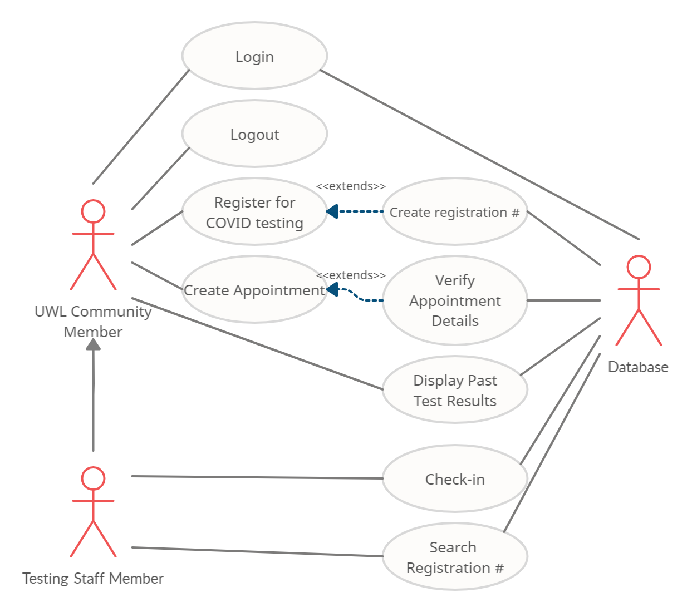

## 

## **Use Case Narratives**

Use Case #: COVID-R1

Use Case name: Register for COVID testing

Input parameters: First name, Last name, UWL email address, Phone number,

Has COVID symptoms

Output parameters: Registration number

Successful scenario:

1. User submits the 5 input parameters above.
2. The UWL email address is validated against the UWL directory to see if the address exists. Display a warning to the user if this validation fails.
3. The phone number is validated for 10 digits of input. Display a warning to the user if this validation fails.
4. Try to generate a valid registration number. (Invoke use case # “COVID-R2”).
5. If all validation and generation are successful, display a message that registration has been completed. Also display the generated registration number.

Use Case #: COVID-R2

Use Case name: Create Registration #

Input parameters: None

Output parameters: Registration number

Successful scenario:

1. On invocation, try to generate a registration number.
2. Check if that registration number is unique and does not exist for another registered user. If that number exists, attempt to regenerate a new registration number.
3. If the registration number is unique, return a registration number.

Use Case #: COVID-L1

Use Case name: Login

Input parameters: UWL email address, Password

Output parameters: None

Successful scenario:

1. User submits two input parameters.
2. Both parameters are validated in the UWL directory for format and completeness.
3. If both parameters are valid, the user is shown if they are registered for testing. Also show their test results and display their appointment if they have already registered or have been tested.

Use Case #: COVID-L2

Use Case name: Logout

Input parameters: None

Output parameters: None

Successful scenario:

1. User submits a request to logout.
2. Terminate access to application and system.
3. Display home screen.

Use Case #: COVID-A1

Use Case name: Create Appointment

Input parameters: Registration number

Output parameters: None

Successful scenario:

1. User submits a registration number.
2. If the user is logged in, use their given registration number if and only if they already generated a registration number with their UWL email.
3. Using a calendar, ask the user to create an appointment.
4. Verify appointment times and display valid appointments to the user. (Invoke use case # “COVID-A2”)
5. If all is valid, display a message with that an appointment has been made to the user.

Use Case #: COVID-A2

Use Case name: Verify Appointment

Input parameters: None

Output parameters: None

Successful scenario:

1. Verify an appointment with time ranges from 10:00 A.M. to 2:00 P.M. in 30 minute intervals (10:00, 10:30, 11:00, ... ).
2. Invalidate 30 minute time intervals that have more than four users who have already created an appointment for that time interval.
3. Display valid appointments for the calendar for use case # “COVID-A1”.

Use Case #: COVID-D

Use Case name: Display Past Test Results

Input parameters: Registration number, Date

Output parameters: COVID test result, First name, Last name, UWL email address,

Phone number, Has COVID symptoms

Successful scenario:

1. If a user is logged in as a UWL community member, given a past registration number and past date, display their past COVID test results and other output parameters.

Use Case #: COVID-C

Use Case name: Check-in

Input parameters: Registration number

Output parameters: None

Successful scenario:

1. If a user is logged in as a UWL COVID testing staff member, given a registration number, check in the person with that registration number for the appointment time.
2. Test the person for COVID. (Generate a COVID test result)
3. If the person had no symptoms and their test result is Negative, then no other appointment is needed.
4. If the person had no symptoms and their test result is Positive, then another appointment should be scheduled a week later.
5. If the person had symptoms and their test result is Negative, then no other appointment is needed.
6. If the person had symptoms and their test result is Positive, then another appointment should be scheduled within a week.

Use Case #: COVID-S

Use Case name: Search Registration #

Input parameters: Integer string

Output parameters: List of registration numbers

Successful scenario:

1. A testing staff member, submits an integer string.
2. Validate string for valid integer.
3. If the input is a valid integer, then return a list of registration numbers that match the integer string.

## **GUI Design Sketches (9 Pages)**

**Page 1-1 (No Logged in User)**

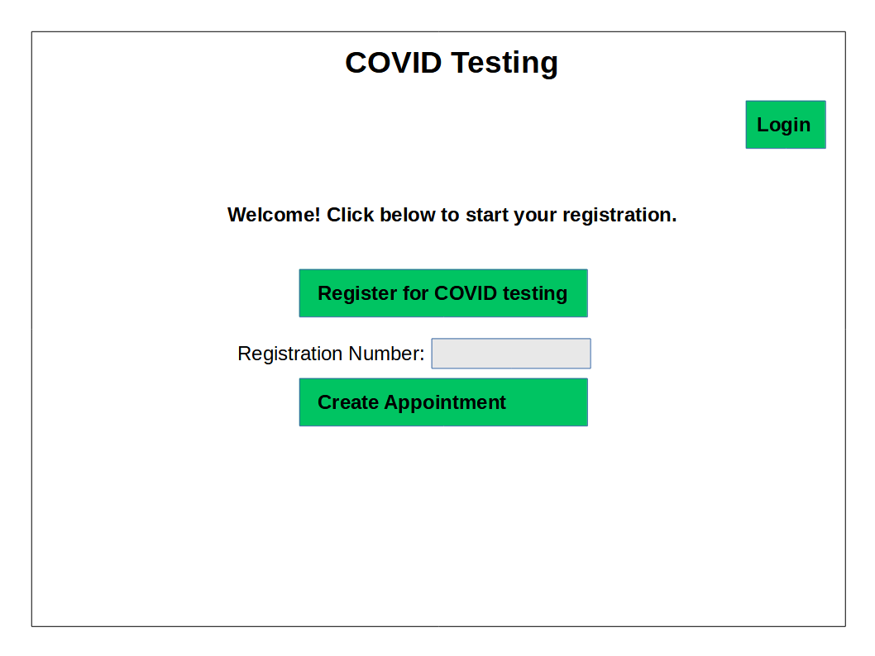

**Page 1-2 (Logged In as UWL community member)**

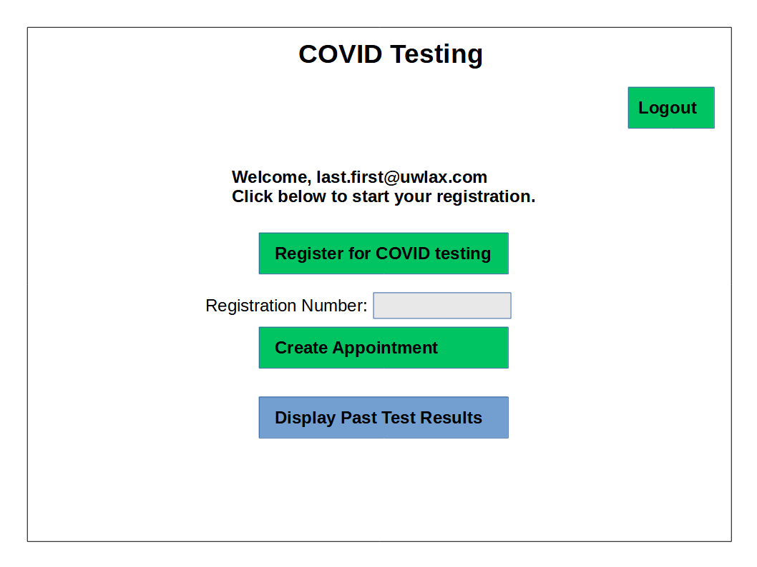

**Page 1-3 (Logged In As Staff)**

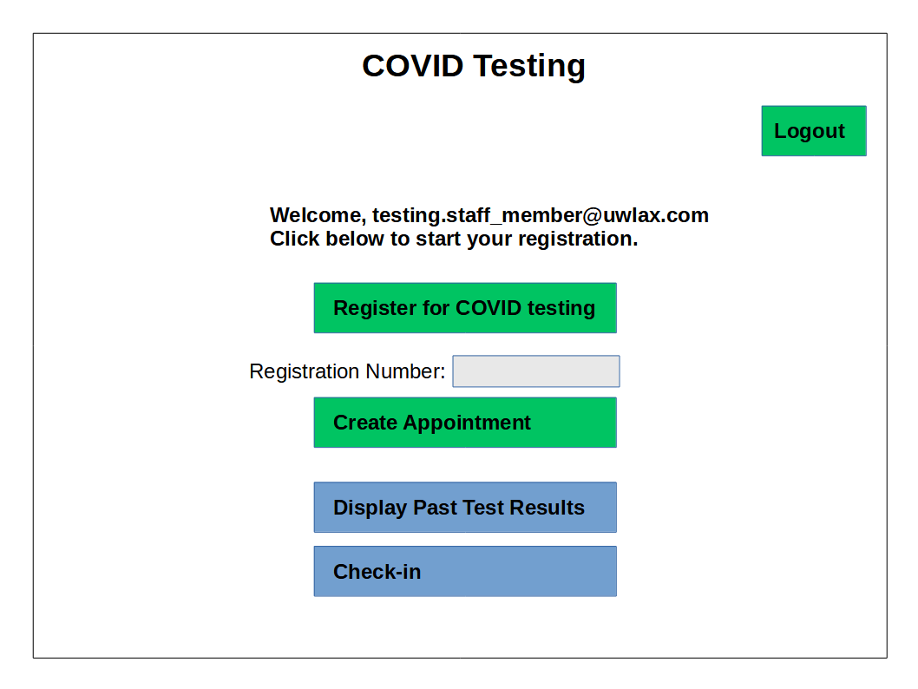

**Page 2 (Login)**

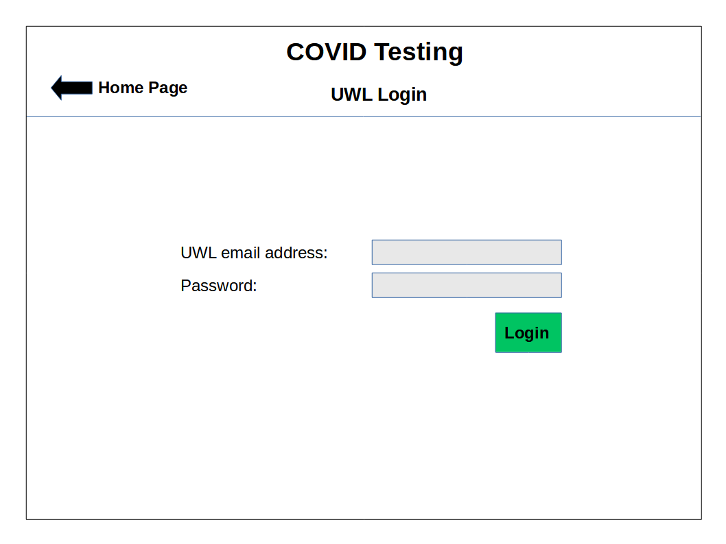

**Page 3 (Registration - Step 1: Provide the information below.)**

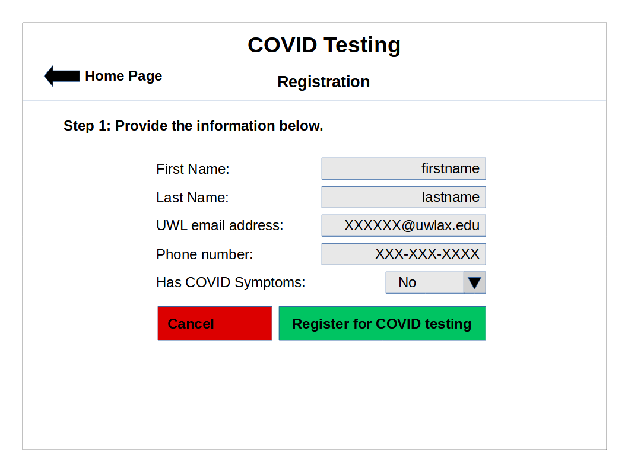

**Page 4 (Registration - Completed)**

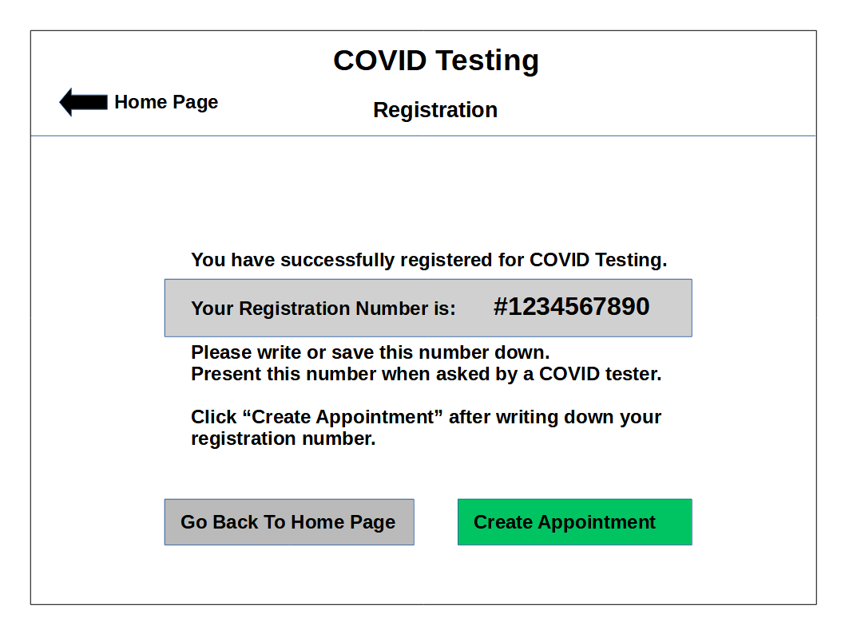

**Page 5 (Create Appointment - Step 1: Select a Date)**

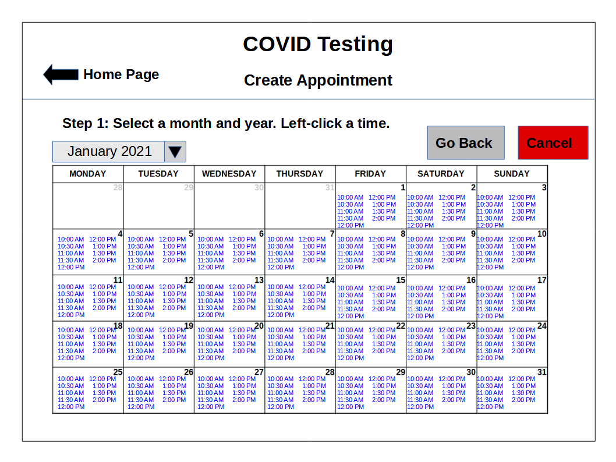

**Page 6 (Create Appointment - Step 2: Confirmation)**

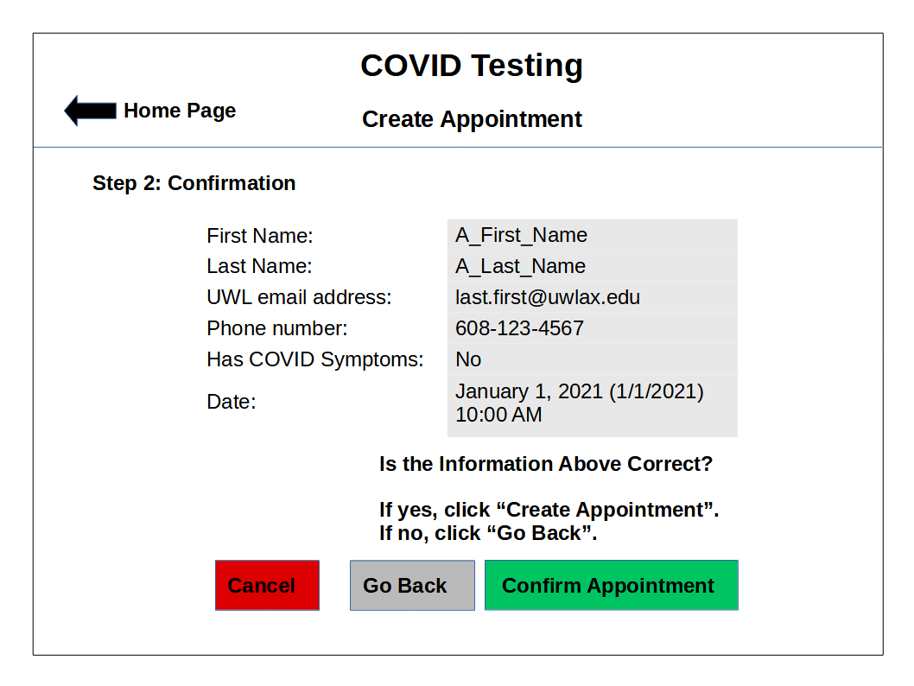

**Page 7 (Create Appointment - Completed)**

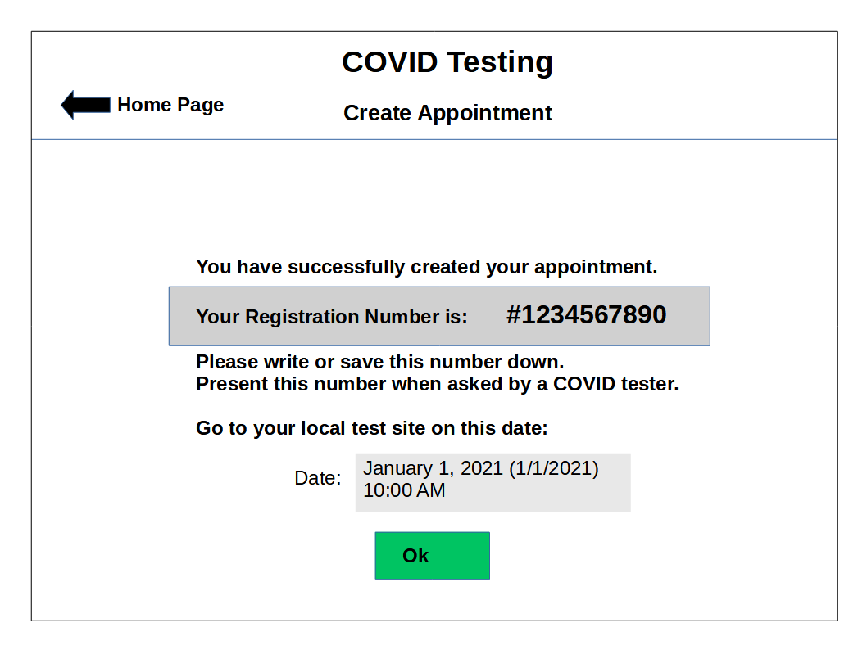

**Page 8 (Display Past Test Results)**

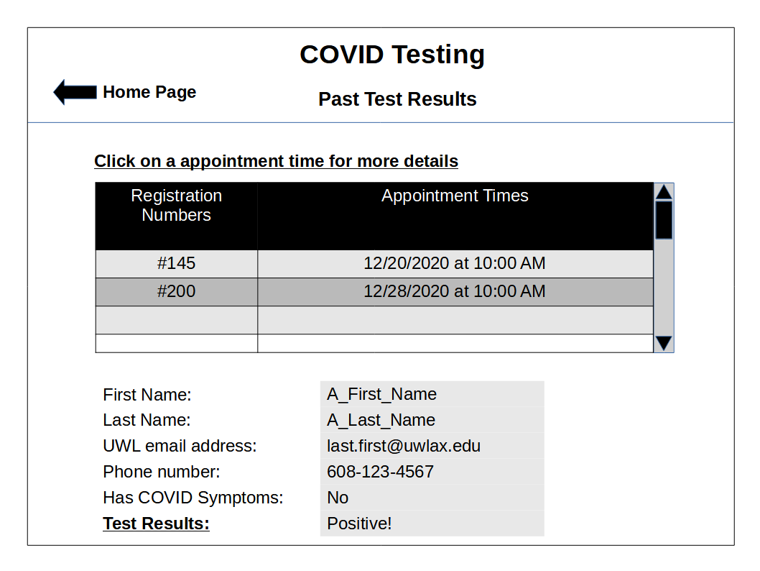

**Page 9 (Check-in)**

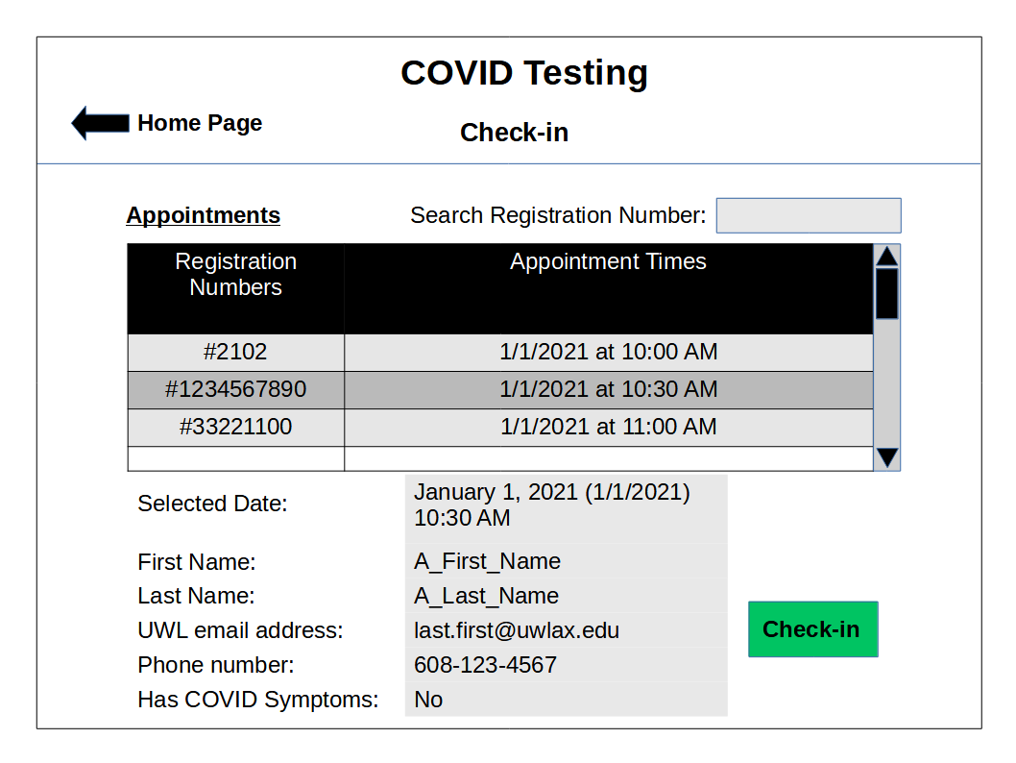

**Page 10-1 (Check-in Test Results; Positive without COVID symptoms)**

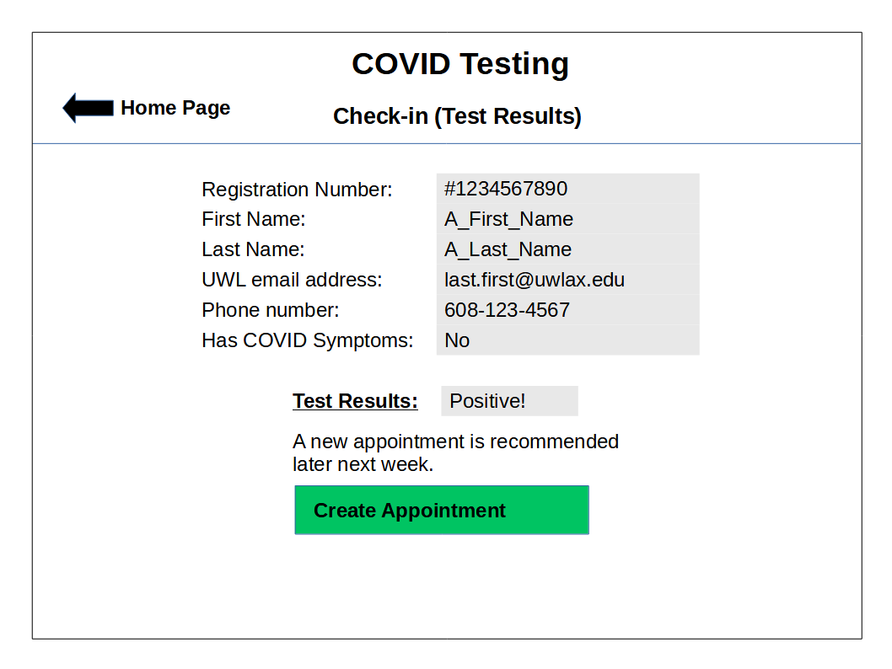

**Page 10-2 (Check-in Test Results; Positive with COVID symptoms)**

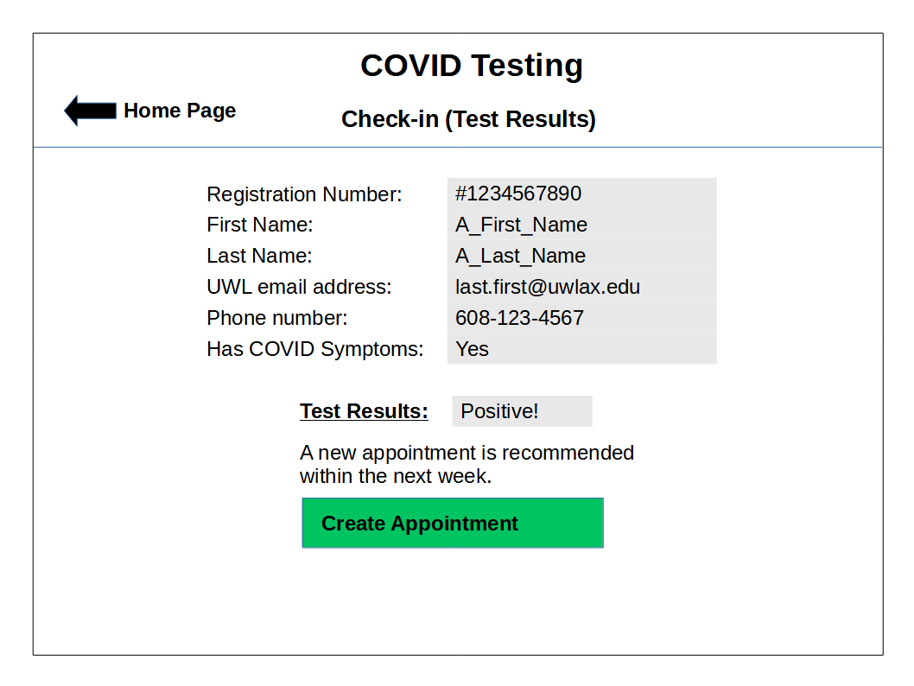

**Page 10-3 (Check-in Test Results; Negative with/without COVID symptoms)**

